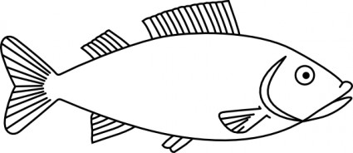

**A "poisson d'avril" is a joke made on April 1st. In France, children try to stick a fish picture on their friends' back. When the joke is discovered, they shout "poisson d'avril !"**

**A "poisson d'avril" is a joke made on April 1st. In France, children try to stick a fish picture on their friends' back. When the joke is discovered, they shout "poisson d'avril !"**

**A "poisson d'avril" is a joke made on April 1st. In France, children try to stick a fish picture on their friends' back. When the joke is discovered, they shout "poisson d'avril !"**

**A "poisson d'avril" is a joke made on April 1st. In France, children try to stick a fish picture on their friends' back. When the joke is discovered, they shout "poisson d'avril !"**

**A "poisson d'avril" is a joke made on April 1st. In France, children try to stick a fish picture on their friends' back. When the joke is discovered, they shout "poisson d'avril !"**

**A "poisson d'avril" is a joke made on April 1st. In France, children try to stick a fish picture on their friends' back. When the joke is discovered, they shout "poisson d'avril !"**